

Summer Night City
A Photographic Exhibition
By David Lydiate
1st Aug – 21st Sept 2007 Central Library William Brown St Liverpool
2nd Floor Business & Technology Department (by city model)

PLEASE GIVE TO LEUKAEMIA RESEARCH
http://www.lrf.org.uk/
Tel: 020 7405 0101
Fax: 020 7405 3139
Email: info@lrf.org.uk
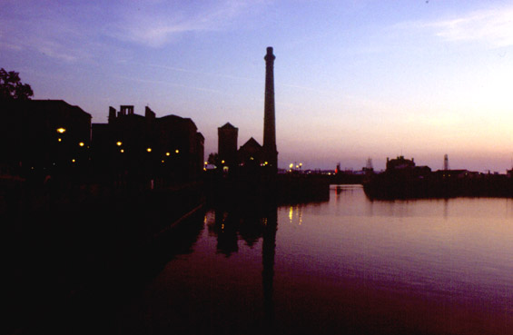
Prints are available on request (please email me if you would like to order one), the sales of which will raise money for
LEUKAEMIA RESEARCH

